**9/14/23**

#html = hyper-text markup language

W3schools.com gives a demo of designing basic webpages

“a” in visual studio code automatically sets up hyperlink line

“../” = ascending 1 level in folders

“../../” = ascending 2 levels in folders

There’s typically one CSS file for each website

You can google HTML elements list to change overall design of website

**10/2/23**

css units, width, margin, font size

relative units scale better for diff devices

16 = default font size

width/height properties adjust box container size for text; min/max can be set to organize page better

block elements - use space advantageously

inline elements - warp with text

css - write "display: inline/block" to convert one type to other"

"margin: 0 auto;" means centering text/element

"nth-of-type(#) allows for specifying certain element from list

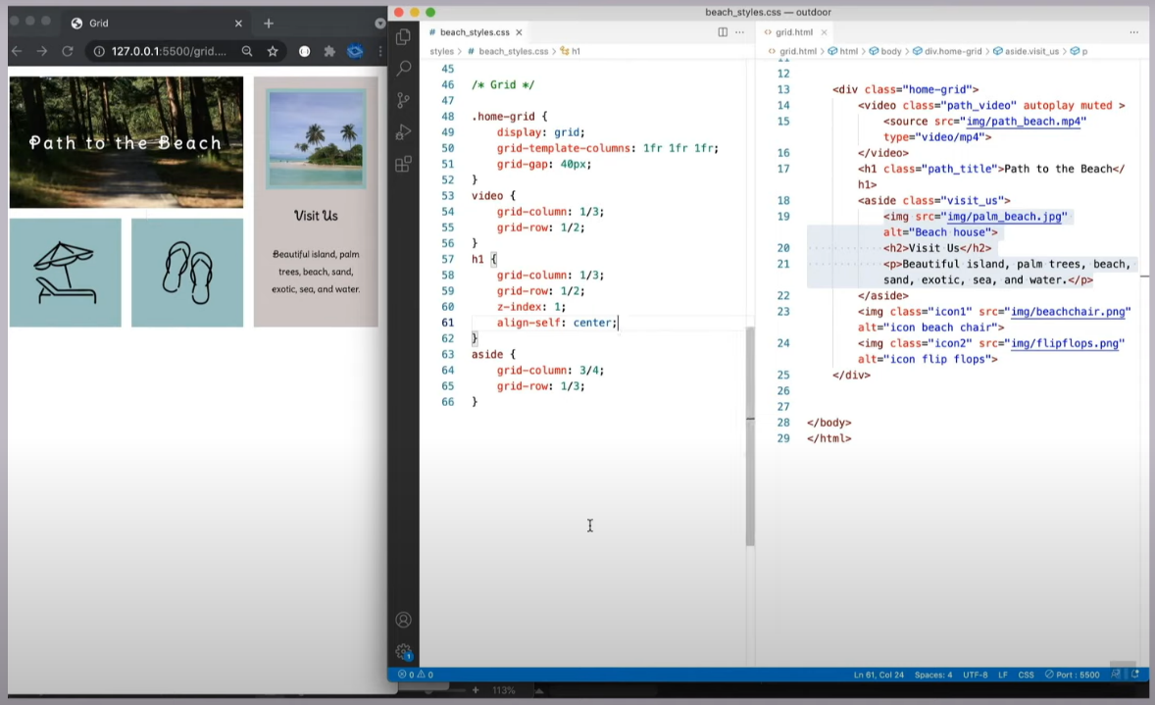 **10/19/23**

Code for  
grid-columns: